Project Design Phase-II
Technology Stack (Architecture & Stack)

Date | 30 September 2026
Team ID | SWTID-2026-7062
Project Name | AL BLOG NEST
Maximum Marks | 4 Marks

Technical Architecture:
The Deliverable shall include the architectural diagram as below and the information as per the table1 & table 2
AL BLOG NEST – Technical Architecture
Guidelines:
Include all the processes (As an application logic / Technology Block)
Provide infrastructural demarcation (Local / Cloud)
Indicate external interfaces (third party API’s etc.)
Indicate Data Storage components / services
Indicate interface to machine learning models (if applicable)
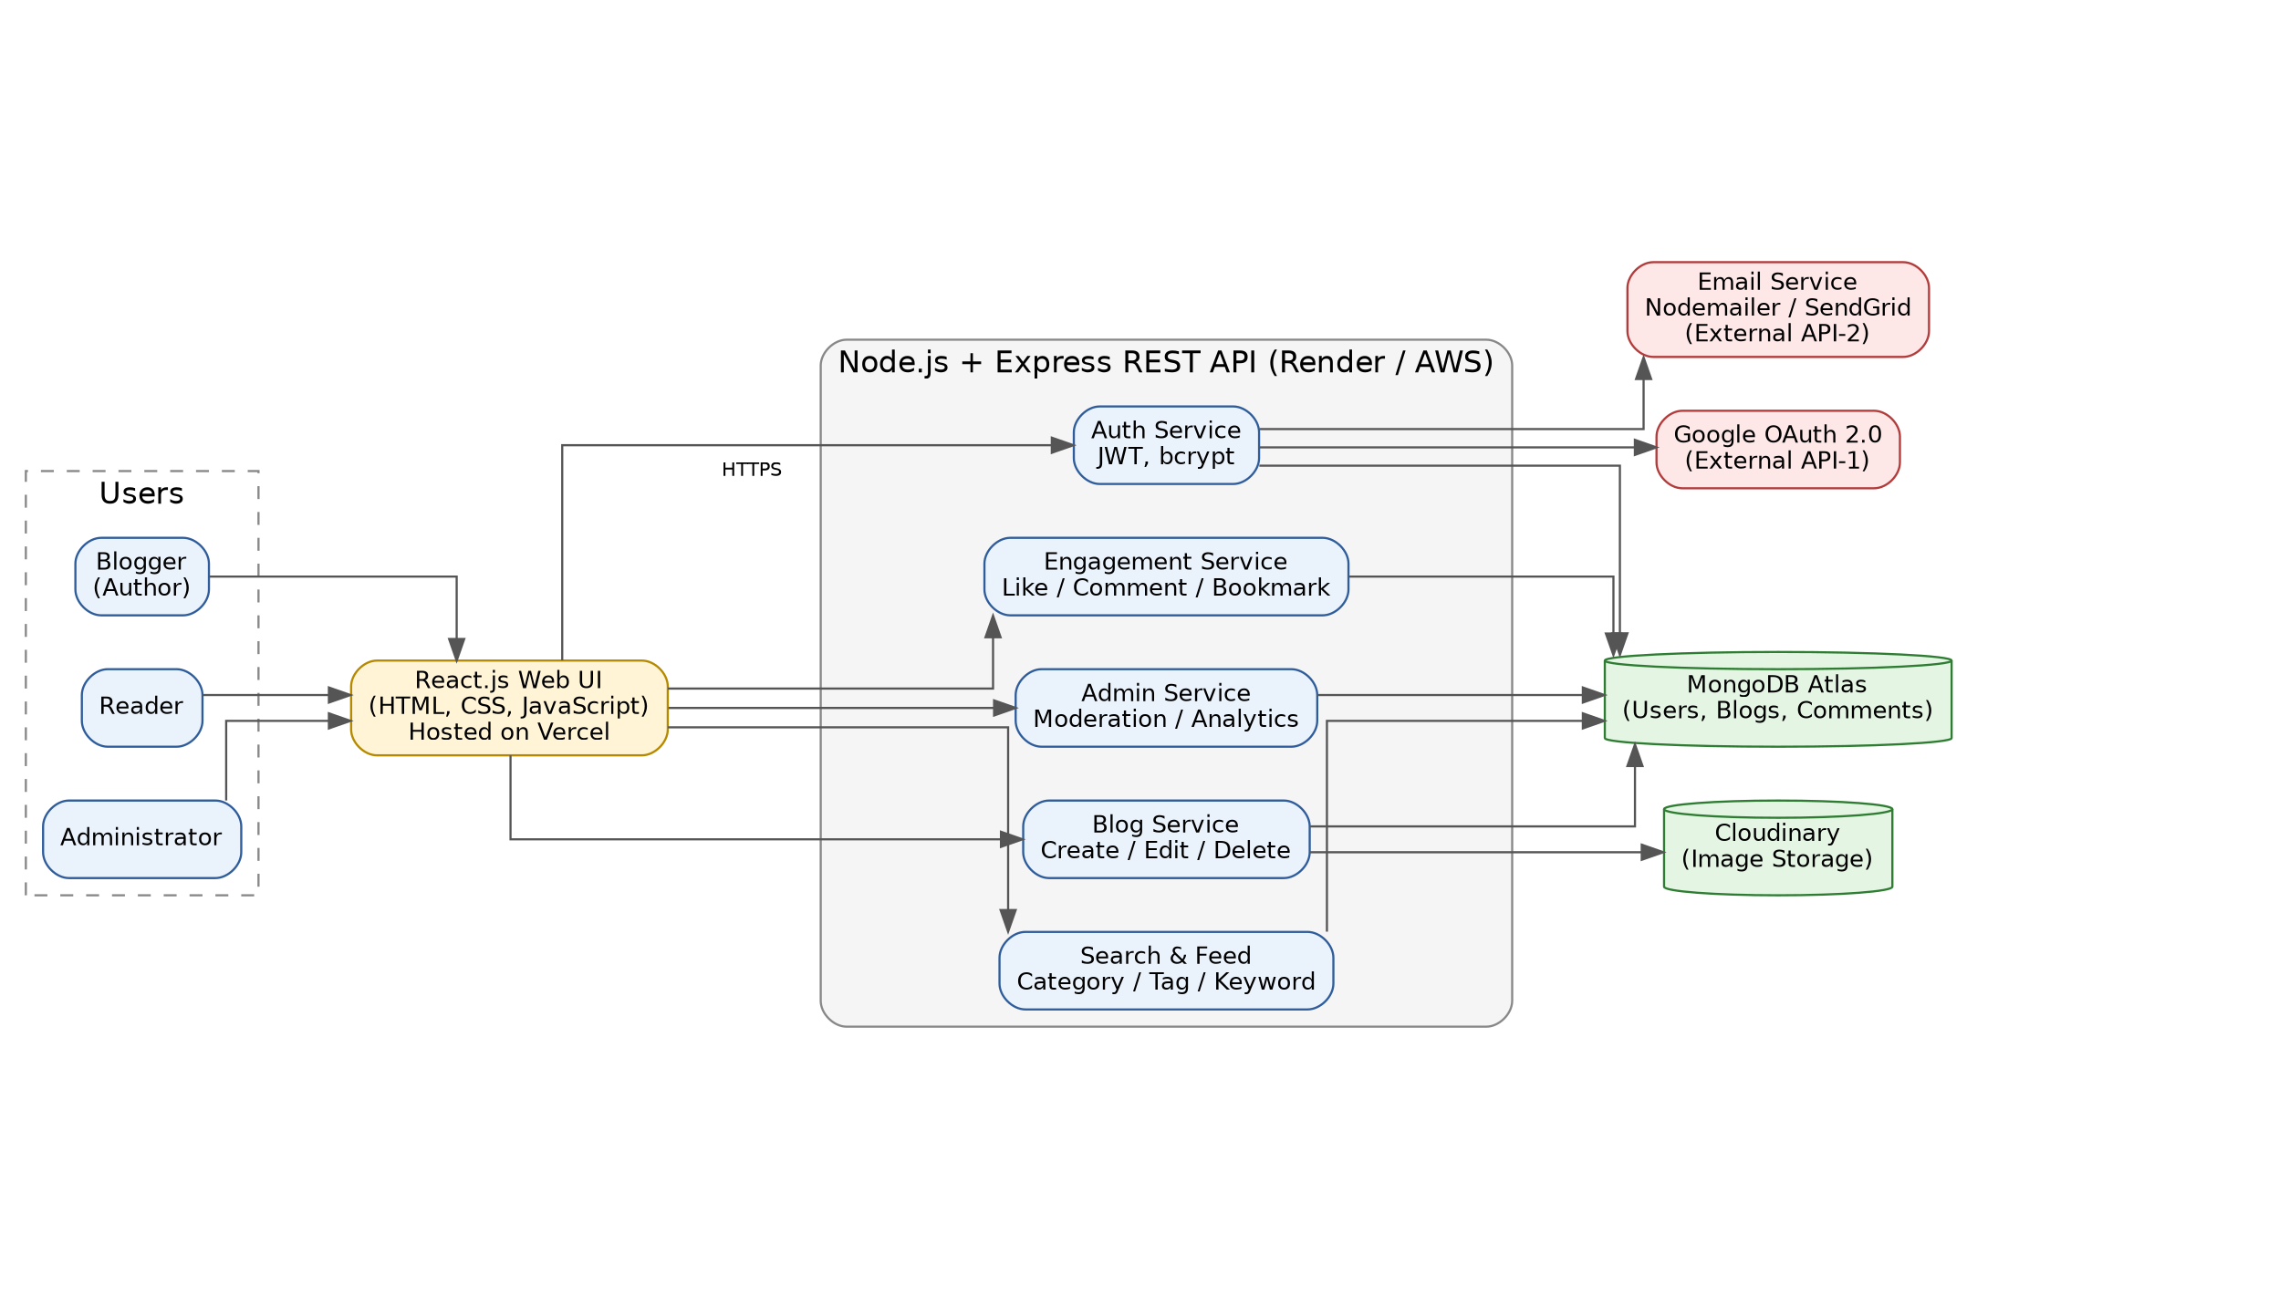

Table-1 : Components & Technologies:
S.No | Component | Description | Technology
 | User Interface | Responsive web UI for bloggers, readers and admin to write, browse and manage blogs | HTML, CSS, JavaScript, React.js, Tailwind CSS
 | Application Logic-1 | Authentication & authorization: registration, login, email verification, password reset, role-based access | Node.js, Express.js, JWT, bcrypt
 | Application Logic-2 | Blog management: create, edit, delete, draft / publish, categories and tags, image upload | Node.js, Express.js, REST APIs
 | Application Logic-3 | Search, feed and engagement: keyword search, filters, likes, comments, bookmarks, follow, admin moderation | Node.js, Express.js, MongoDB text indexes
 | Database | Stores users, blog posts, comments, likes and bookmarks as documents | MongoDB (NoSQL), Mongoose ODM
 | Cloud Database | Managed cloud database service with replication and backups | MongoDB Atlas
 | File Storage | Storage of blog cover images and profile pictures with CDN delivery | Cloudinary
 | External API-1 | Sign-in / registration through Gmail | Google OAuth 2.0 API
 | External API-2 | Sending verification, welcome and password-reset emails | Nodemailer / SendGrid API
 | Machine Learning Model | Not used in version 1.0. Planned: content-based blog recommendation and tag suggestion | Not applicable (future: TF-IDF / NLP model)
 | Infrastructure (Server / Cloud) | Application deployment on local system / cloud  Local Server Configuration: Node.js (LTS), MongoDB, 8 GB RAM, Windows / Linux, VS Code  Cloud Server Configuration: frontend on Vercel; backend on Render / AWS EC2 (1 vCPU, 1–2 GB RAM); database on MongoDB Atlas | Local, Vercel, Render / AWS EC2, MongoDB Atlas, Git & GitHub

Table-2: Application Characteristics:
S.No | Characteristics | Description | Technology
 | Open-Source Frameworks | React.js for the UI, Express.js for the REST API, Mongoose for data modelling | React.js, Node.js, Express.js, Mongoose, Tailwind CSS
 | Security Implementations | Password hashing, token-based authentication, role-based access control, input validation, CORS, rate limiting and HTTPS | bcrypt, JWT, Helmet, express-validator, OWASP Top-10 practices, HTTPS / TLS
 | Scalable Architecture | 3-tier architecture (presentation, application, data) with a stateless API; modules can be split into micro-services as load grows | React.js + Node.js / Express + MongoDB Atlas
 | Availability | Cloud hosting with health checks and auto-restart, replicated database, and a load balancer to distribute traffic across API instances | Render / AWS EC2 with Load Balancer, MongoDB Atlas replica set
 | Performance | Pagination, database indexes, caching of popular posts, image compression and CDN delivery keep responses fast | MongoDB indexes, in-memory cache / Redis (optional), Cloudinary CDN, Vercel CDN

References:
https://c4model.com/
https://developer.ibm.com/patterns/online-order-processing-system-during-pandemic/
https://www.ibm.com/cloud/architecture
https://aws.amazon.com/architecture
https://medium.com/the-internal-startup/how-to-draw-useful-technical-architecture-diagrams-2d20c9fda90d

